**TDO2 (Tryptophan 2,3-Dioxygenase) as a Novel Target for the Diagnosis and Treatment of Triple Negative Breast Cancer**

Abigail Tsuji

**Abstract**

Triple Negative Breast Cancer (TNBC) is an extremely aggressive disease associated with increased recurrence risk and poor survival rates. Identified by the negative expression of the human epidermal growth factor receptor 2 and the hormone receptors: estrogen and progesterone receptor, it is responsible for 10-15% of all breast cancers (American Cancer Society 2021). Several studies have demonstrated the importance of programmed cell death protein 1 in aiding immunosuppressive microenvironments and the involvement of the kynurenine pathway in tumors. Importantly, the amino acid tryptophan is broken down in the kynurenine pathway. The tryptophan-catabolizing enzyme, TDO2, plays an important role in tryptophan degradation, though little research has been done on the expression of TDO2 in TNBC specifically. Based on the existing literature, I hypothesized that TDO2 levels will be higher in TNBC samples compared to non-TNBC breast cancer or normal tissue samples. A Wilcoxon test was applied to compare Invasive Breast Carcinoma tissue and normal breast TDO2 levels within the TIMER 2.0 database. The Oncomine database was used to make comparisons between normal and TNBC, and I assessed the effect of TDO2 expression on recurrence-free survival in both non-TNBC (ER/PR/HER2+) and TNBC tissues from the Kaplan-Meier database.In this study, I identified higher amount of TDO2 in Breast Invasive Carcinoma patients (p value of 1.26E-52) and TNBC patients (p value of 1.35E-162), as well as a significant association between free-recurrence survival and TDO2 levels in TNBC samples (p value of 0.36). These findings demonstrate the importance of identifying novel potential strategies for TNBC therapies and treatments, with more focus on developing drugs that target TDO2.

**Introduction**

The most common cancer in women is breast cancer, with an estimated 1.67 million new cases diagnosed worldwide in 2012 (Cardosa 2016). In fact, in January 2019, over 3.8 million US women had history of breast cancer (Miller 2019). Triple Negative Breast Cancer (TNBC) is an extremely aggressive disease identified by the negative expression of human epidermal growth factor receptor 2 (HER2) and the hormone receptors estrogen receptor (ER) and progesterone receptor (PR) (Rakha 2009). Due to a lack of effective targeted therapies, patients with TNBC are increasingly at risk for tumor recurrence, poor overall prognoses, and lower five-year survival rates than individuals with other subtypes of breast cancer (Shimelis 2018). Therefore, novel therapeutic schemes specific to improve TNBC patient**s** are needed (Qiang Liu 2020).

Immunosurveillance is the body’s immune system to detect and destroy unwanted cells and malignancies (Beatty 2014). Tumors can escape elimination and still grow despite immunosurveillance. CD8 T-cells, the main anti-tumor immune response, have the role of recognizing specific tumor antigen molecules in order to kill these cancer cells. However, the decline of T-cell function, also referred to as T-cell exhaustion, leads to tumor cells being able to escape immunosurveillance, since the tactic of targeting specific molecules is repeatedly used (Lorenzo-Herrero 2019). Tumor cells that escape cell death learn to avoid immune responses in order to grow, through a process called immunoediting (Rao 2018). Thus, through immunoediting, tumor cells can change immune response to allow them to thrive.

As of recently, various investigations have clarified immune checkpoint vitality in controlling malignant immunity. The immune checkpoint, programmed cell death 1 (PD1), interacts with programmed death ligand 1 (PD-L1) aiding the immunosuppressive microenvironments in tumors when bounded (Mittendorf 2014). The responsibility of PD-L1 and PD-1 is to prevent the destruction of immense amounts of tissue, thus serving as an immune checkpoint. As shown in Figure 1, PD-1 is a cell surface receptor on T-cells. Tumors can express PD-1's ligand, PD-L1, and inhibit T cell proliferation (Webb 2015). Therefore, if the PD-L1 and PD1 process is disturbed with antibodies, T cell function and anti-tumor immunity is returned and strengthened (Sunshine 2015). Notably, PD-L1 expression was identified in 72% of TNBC cases, while PD-L1 expression was identified between the range of 0-46% in other breast cancer types. PD-L1 expression was also positively associated with overall survival in TNBC (Zhang 2019). Because of PD-L1's large presence in TNBC, PD-L1 is suggested tobe a therapeutic target in TNBC. Therefore, it is vital to identify PD-L1 as a novel potential target for TNBC immunotherapy.

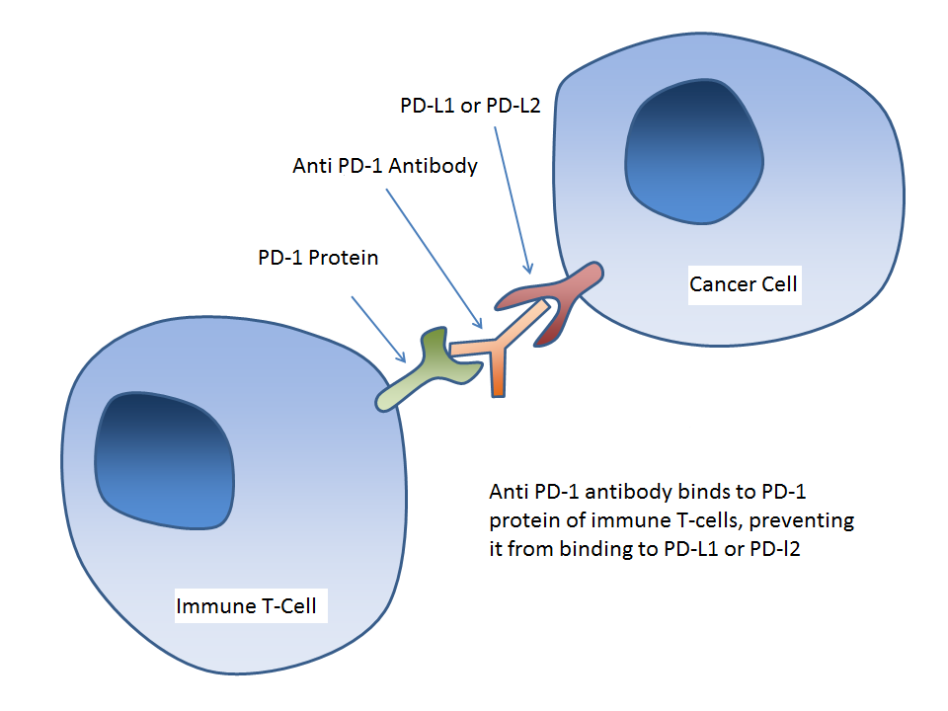

*Figure 1. Though cancer cells can overexpress the PD-1 ligand, PD-L1, antibodies can block negative signals from cancer cells (Felix 2016.)*

Tryptophan, an amino acid, is essential for producing protein to aid in cell proliferation. In the kynurenine pathway, 95% of tryptophan is broken down leading to the formation of catabolites that affect immune response and promote tumor progression (Liu 2021). The kynurenine pathway is involved in the regulation of immunosuppression in the cancer environment. As shown in Figure 2, tryptophan depletion in this pathway results in the generation of tryptophan metabolites, resulting in T cell inhibition and apoptosis (Eller 2015). Cells create the tryptophan catabolite kynurenine with the use of tryptophan 2,3-dioxygenase (TDO2), a tryptophan degrading enzyme. TDO2-derived kynurenine suppresses antitumor immune responses, which promotes tumor cell survival (Opitz 2011). Importantly, the main tryptophan-catabolizing enzyme TDO2 plays an important role in tryptophan degradation, as TDO2 causes tryptophan starvation. The starvation of tryptophan is significant because it causes an increase in kynurenine, which may lead to cancer growth. TDO2 and Indoleamine 2,3-dioxygenase 1 (IDO1) are the first rate-limiting step, as they regulate systemic tryptophan reduction and kynurenine accumulation, therefore promoting tumorigenesis. However, only limited research has concentrated on TDO2 responsibility in immune regulation, so future studies could lead to the creation of TDO2 as a novel target in breast cancer treatments and immunotherapy.

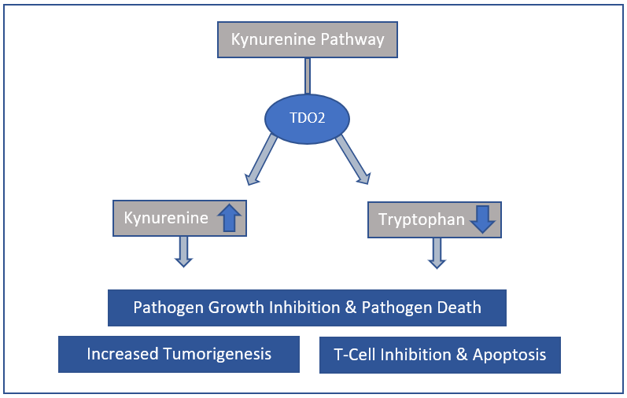

*Figure 2. Kynurenine Pathway and the effects of kynurenine accumulation and tryptophan depletion on T cell growth, tumor growth, and pathogen growth.*

Previous studies indicate that TDO2 is involved in initiating late-stage breast cancer metastasis, facilitating anoikis resistance and cytotoxic T cells of the immune system, and inhibiting CD8 T cell proliferation (Greene 2018). Anoikis is a programmed cell death process where normal epithelial cells are set to undergo apoptosis, or cell death, once detached from the breast (D’Amato 2015). Because cancer cells are faced with anoikis after detachment, they must form anoikis resistance in order to survive. Thus, as cancer cells circulate the body, tumor metastasis is formed (Kim 2012). These studies indicate that TDO2 is a promising immunotherapy target for breast cancer, although its specific role and relation with immune infiltration remains unclear.

Despite the plethora of studies that have established TDO2’s role in activating immunosuppression in cancers, there is a lack of studies that directly examine the effect TDO2 may have on TNBC patient outcomes**.** Previous literature has demonstrated that TDO2 has great potential as an immunotherapy target in TNBC and that TNBC patients still suffer from clinical outcomes like early relapse and metastasis (Park 2018). Thus, I hypothesize that TDO2 expression in TNBC will be higher than TDO2 in non-TNBC and higher in worse recurrence-free survival. The goal of this study is to determine the expression of TDO2 in breast cancer by using transcriptome data to explore the consequences of TDO2 expression on clinical outcomes.

**Methodology**

*Timer 2.0 Database*

Before exclusively looking at TNBC samples, I used the TIMER 2.0 database in order to investigate the amount of TDO2 levels in regular breast cancer tumor tissue versus normal breast tissue. The TIMER 2.0 is the newest version of the TIMER database, which is a comprehensive platform for the analysis of immune infiltrates across 32 cancer types from The Cancer Genome Atlas (TCGA) database (Li 2020). In order to discover the differential expression of TDO2 between 1,093 Invasive Breast Carcinoma cancer tissues and 112 normal tissues of TCGA samples, the Gene_DE unit was applied. Next, the Wilcoxon test found in the Gene_DE module of the TIMER 2.0 database was implemented with the significance difference of p of 0.001.

*Oncomine Database*

mRNA TDO2 expression levels in Curtis TNBC tissue and normal breast tissue were compared using differential expression in the Oncomine database. Oncomine is a database for creating cancer profiles with a total of 715 records and 86,733 samples (Oncomine Login). 144 normal breast samples and 1,556 TNBC Invasive Breast Carcinoma samples were identified and compared. The threshold for analysis p value, fold change, and gene ranking was set as: 0.05, 2, and the top 10 %.

*Kaplan-Meier Plotter Database*

The Kaplan-Meier plotter can evaluate the impact of 54,000 distinct genes on 21 malignancy types and their survivals (Györffy 2010). Kaplan-Meier, containing 6,234 samples from databases including TCGA, was used to assess TDO2 expression on the patient outcome, recurrence-free survival, with a p value of 0.05, which was set calculated by the database. A cutoff value of 261 calculated by the database was used in analysis of TDO2 and its effect on recurrence-free survival.

**Results & Analysis**

*High TDO2 Expression in BRCA*

In order to study the TDO2 differential expression between Breast Invasive Carcinoma tumor and regular tissue of breast cancer, as well as various other cancer types, the Gene_DE module of TIMER 2.0 across all TCGA tumors was used. Statistical significance was also computed. The differential gene expression included in figure 2 between tumor and normal tissues in the Gene_DE module include: Bladder Urothelial Carcinoma (BLCA), Cervical and Endocervical Cancer (CESC), Cholangiocarcinoma (CHOL), Colon Adenocarcinoma (COAD), Esophageal Carcinoma (ESCA), Glioblastoma Multiforme (GBM), Head and Neck Cancer (HNSC), Kidney Chromophobe (KICH), Kidney Renal Cler Cell Carcinoma (KIRC), Liver Hepatocellular Carcinoma (LIHC), Lung Adenocarcinoma (LUAD), (Lung Squamous Cell Carcinoma (LUSC), Pancreatic Adenocarcinoma (PAAD), Pheochromocytoma and Paraganglioma (PCPG), Prostate Adenocarcinoma (PRAD), Rectum Adenocarcinoma (READ), Skin Cutaneous Melanoma (SKCM), Stomach Adenocarcinoma (STAD), Thyroid Carcinoma (THCA), Uterine Corpus Endometrial Carcinoma (UCEC). Although this study only focuses on breast cancer, the Gene_DE module includes all TCGA tumors, so data about other tumors were included.

Although all cancers were included in the data sample, I investigated the Breast Invasive Carcinoma tumor tissue and tissues specifically. According to Figure 3, the BRCA tissues had a p value of 1.26E-52, demonstrating high significance. This demonstrated that the breast cancer tumor tissues had a greater amount of TDO2 when compared with normal breast tissues.

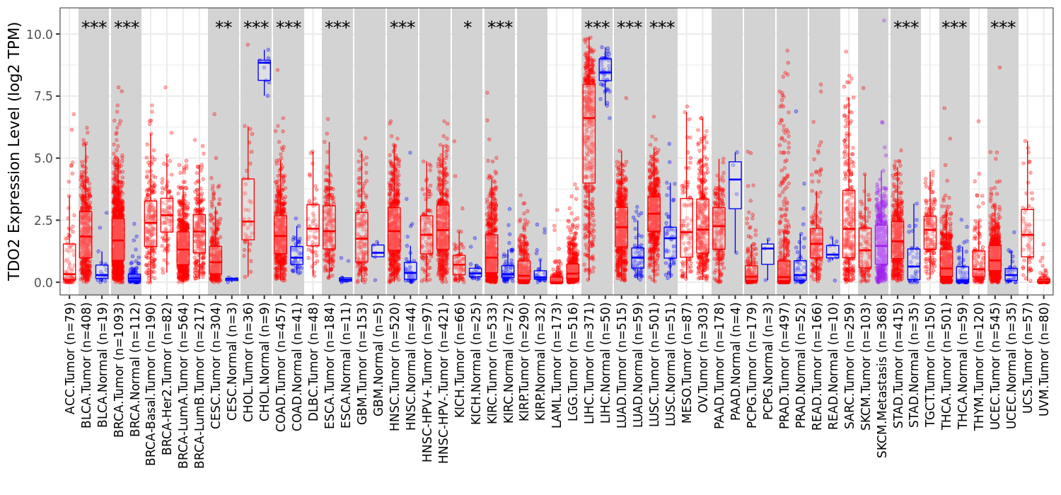

Figure 3 TDO2 expression levels in all TCGA tumors and its adjacent regular tissue samples within the TIMER 2.0 database (*p<0.05, **p<0.01, ***p<0.001) Bars are colored as follows: red = tumor tissues, blue = normal adjacent tissues, purple = tumor and normal tissues

*TDO2 Overexpression in TNBC*

In order to determine whether TDO2 was overexpressed in TNBC tissues compared to normal breast tissues, 2,136 samples in the Oncomine database were selected within the 2014 Nature Curtis Breast TNBC. The differential analysis filter, “Breast Cancer vs. Normal Analysis”, was also placed. After comparing 1,992 breast carcinoma samples and 144 normal breast samples, with an over-expression gene rank of 1 percent, I found the p value and Fold Change values (1.35E-162, and 2.094, respectively). The results demonstrate that TDO2 is overexpressed by a factor of 2.094 in TNBC patients compared to controls (Figure 4).

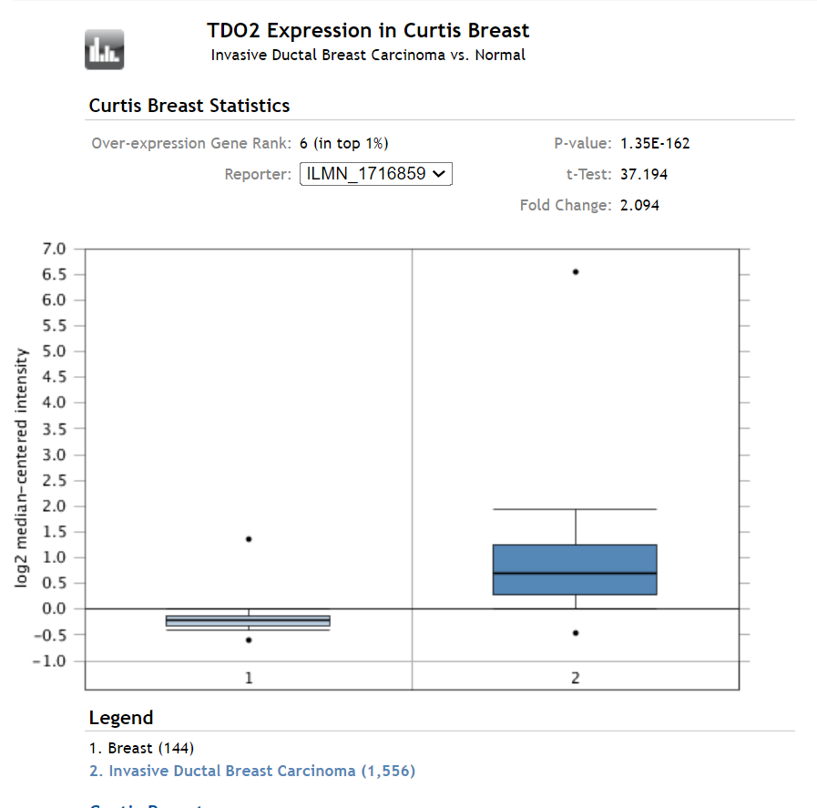 *Figure 4. Oncomine dataset comparing normal breast tissue and Triple Negative Breast Invasive Ductal Carcinoma tissue.*

*Worse Recurrence-Free Survival in TNBC*

To determine the recurrence-free survival of the mRNA of TNBC with TDO2 and non-TNBC with TDO2, I used the Kaplan-Meier plotter database. As shown in figures 5 and 6, it was concluded from the Kaplan-Meier plotter database that the TNBC log rank p value was 0.36, and the non-TNBC log rank p value was 0.95. The TNBC set contained a cutoff value of 260, a low expression cohort of TDO2 at 30 months, and a high expression cohort of TDO2 at 27.34 months. The non-TNBC contained a cutoff value of 219 in the analysis, with low/high expression cohorts that were not accessible. The non-TNBC samples also contained ER positive, PR positive, and HER2 positive receptors. TDO2 expression does not correlate with survival in non-TNBC patients but is trending toward significance in the TNBC population with high TDO2 levels predictive of worse survival.

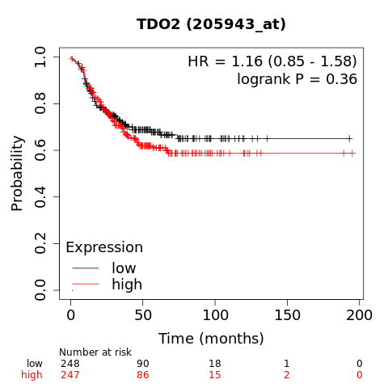

Figure 5. Kaplan-Meier Survival Curve displaying probability, time, and the high and low expression of TDO2 in Triple Negative Breast Cancer

**Discussion**

With a high risk of recurrence at 1-3 years after diagnosis, TNBC has a high recurrence when compared to other breast cancer subtypes (Rogers 2018). In this study, the hypothesis that TDO2 expression and worse recurrence-free survival in TNBC samples is higher than non-TNBC samples was fully supported. In order to fulfill the goal of determining the expression of TDO2 in breast cancer with transcriptome data, the TIMER 2.0 database were used. Using the “Gene_DE” module in the TIMER 2.0 database, I compared regular breast cancer samples and breast cancer tumor samples. 1,093 Invasive Breast Carcinoma cancer tissue samples were used, while only 112 normal tissue samples were used. Although findings suggest there is an abundance of TDO2 in Breast Cancer overall, there is still a need for validation through larger and equal sample sizes for clearer results, despite database limitations. Because of this significantly high TDO2 amount, I was determined to explore TDO2 levels in TNBC further.

It was recognized that TDO2 expression in the Oncomine database TNBC group was significantly higher than the normal breast tissue group. TDO2 was shown to be upregulated based on increased mRNA expression, implying that there is upregulation of the kynurenine pathway. Due to kynurenine pathway hyperactivity, tumor immune responses are promoted by TDO2-derived kynurenine. Importantly, the main tryptophan-catabolizing enzyme TDO2 plays an important role in tryptophan degradation because TDO2 causes tryptophan starvation. Nonetheless, like the TIMER 2.0 database, the number of samples with normal breast tissue was small with only 144 samples, compared to the 1,556 the Triple Negative Invasive Ductal TNBC Carcinoma tissues in Oncomine. There is a need for additional studies to include a larger and more equal sample size to further evaluate TDO2 levels in additional cancers other than breast cancer.

Data from the Kaplan Meier plotter database revealed that the association between TDO2 amounts and recurrence-free survival was trending towards significant in the TNBC samples. Data from systemically untreated and treated patients were used, and the ER, PR, and HER2 subtypes were only changed. Therefore, it is unclear if there is a correlation between TDO2 and patient age, lymph node status, cancer grade, or patients with endocrine therapy and/or chemotherapy. Unfortunately, many TNBC patients suffer from clinical outcomes like early relapse and metastasis. Because TNBC has the most aggressive behaviors like risk of relapse within the first 3-5 years after typical chemotherapy treatment (Park 2018), other patient outcome survivals in addition to recurrence-free survival should be tested, as TDO2 may be a contributing factor to the clinical outcomes of breast cancer patients. Future studies should also determine if treatments and cancer grades/stages are a contributing factor to the expression of TDO2 in TNBC.

By using the findings in this study, it is important to further understand the role of TDO2 as a novel target in not just TNBC but possibly other types of human cancers. Although TDO2 has the important role of mediating the immunosuppressive microenvironment for breast cancer, tryptophan-catabolizing enzymes might function collectively in the tumor immune microenvironment. Therefore, future research should focus on multiple catalysts, since focusing on lone catalysts might be insufficient in reversing tumor immune resistance.

**Conclusion**

Overall, TDO2 was overexpressed in TNBC samples, and worse recurrence-free survival in TNBC samples was higher than non-TNBC samples. This study is important in showing that the results may add to our understanding of potential treatments for TNBC. Findings may be significant in adding to our understanding on stopping the reoccurrence of breast cancer, and new therapies focused on TNBC. Future examinations directed on researching the job of TDO2 in immune response regulation may uncover novel experiences for TDO2-intervened immunotherapy, as well as establish inhibitors focusing on numerous enzymes in cancer immunotherapy.

**References**

Cardoso, F., Harbeck, N., Mertz, S., &amp; Fenech, D. (2016). Evolving psychosocial, emotional, functional, and support needs of women with advanced breast cancer: Results from the Count Us, Know Us, Join Us and Here &amp; Now surveys. The Breast, 28, 5-12. doi:10.1016/j.breast.2016.04.004

Damato, N. C., Rogers, T. J., Gordon, M. A., Greene, L. I., Cochrane, D. R., Spoelstra, N. S., . . . Richer, J. K. (2015). A TDO2-AhR Signaling Axis Facilitates Anoikis Resistance and Metastasis in Triple-Negative Breast Cancer. Cancer Research, 75(21), 4651-4664. doi:10.1158/0008-5472.can-15-2011

Eller, S. K., &amp; Däubener, W. (2015). Role of kynurenine pathway in infections. Targeting the Broadly Pathogenic Kynurenine Pathway, 179-190. doi:10.1007/978-3-319-11870-3_14

Felix, J. (2016, February 16). Blog - A Brief Introduction to PD-1 Antibodies and Immunotherapy. https://www.prosci-inc.com/blog/pd-1-antibody-immunotherapy/.

Greene, L. I., Bruno, T. C., Christenson, J. L., D'alessandro, A., Culp-Hill, R., Torkko, K., . . . Richer, J. K. (2018). A Role for Tryptophan-2,3-dioxygenase in CD8 T-cell Suppression and Evidence of Tryptophan Catabolism in Breast Cancer Patient Plasma. Molecular Cancer Research, 17(1), 131-139. doi:10.1158/1541-7786.mcr-18-0362

Györffy, B., Lanczky, A., Eklund, A. C., Denkert, C., Budczies, J., Li, Q., & Szallasi, Z. (2009). An online survival analysis tool to rapidly assess the effect of 22,277 genes on breast cancer prognosis using microarray data of 1,809 patients. Breast Cancer Research and Treatment, 123(3), 725-731. doi:10.1007/s10549-009-0674-9

Kim, Y., Koo, K. H., Sung, J. Y., Yun, U., &amp; Kim, H. (2012). Anoikis resistance: An essential prerequisite for tumor metastasis. International Journal of Cell Biology 1-11. doi:10.1155/2012/306879

Li, T., Fu, J., Zeng, Z., Cohen, D., Li, J., Chen, Q., . . . Liu, X. S. (2020). TIMER2.0 for analysis of tumor-infiltrating immune cells. Nucleic Acids Research, 48(W1). doi:10.1093/nar/gkaa407

Liu, Q., Zhai, J., Kong, X., Wang, X., Wang, Z., Fang, Y., &amp; Wang, J. (2020). Comprehensive Analysis of the Expression and Prognosis for TDO2 in Breast Cancer. Molecular Therapy - Oncolytics, 17, 153-168. doi:10.1016/j.omto.2020.03.013

Liu, X., & Zhai, X... (2021). Role of tryptophan metabolism in cancers and therapeutic implications. Biochimie, 182, 131–139. <https://doi.org/10.1016/j.biochi.2021.01.005>

Lorenzo-Herrero, Seila, et al. “Immunosurveillance of Cancer Cell Stress.” Cell Stress, vol. 3, no. 9, 2019, pp. 295–309., doi:10.15698/cst2019.09.198.

Miller, K. D., Nogueira, L., Mariotto, A. B., Rowland, J. H., Yabroff, K. R., Alfano, C. M., . . . Siegel, R. L. (2019). Cancer treatment and survivorship statistics. CA: A Cancer Journal for Clinicians, 69(5), 363-385. doi:10.3322/caac.21565

Mittendorf, E. A., Philips, A. V., Meric-Bernstam, F., Qiao, N., Wu, Y., Harrington, S., . . . Alatrash, G. (2014). PD-L1 Expression in Triple-Negative Breast Cancer. Cancer Immunology Research, 2(4), 361-370. doi:10.1158/2326-6066.cir-13-0127

Oncomine Login. (n.d.). Retrieved from https://www.oncomine.org/

Opitz, C. A., Litzenburger, U. M., Sahm, F., Ott, M., Tritschler, I., Trump, S., . . . Platten, M. (2011). An endogenous tumour-promoting ligand of the human aryl hydrocarbon receptor. Nature, 478(7368), 197-203. doi:10.1038/nature10491

Park, J. H., Ahn, J.-H., & Kim, S.-B. (2018). How shall we treat early triple-negative breast cancer (TNBC): from the current standard to upcoming immuno-molecular strategies. *ESMO Open*, *3*. https://doi.org/10.1136/esmoopen-2018-000357

Rao, Samhita, et al. “Cancer Immunosurveillance by T Cells.” International Review of Cell and Molecular Biology, 2019, pp. 149–173., doi:10.1016/bs.ircmb.2018.08.001.

Rakha, E. A., &amp; Ellis, I. O. (2009). Triple-negative/basal-like breast cancer: Review. Pathology, 41(1), 40-47. doi:10.1080/00313020802563510

Rogers, T. J., Christenson, J. L., Greene, L. I., O'Neill, K. I., Williams, M. M., Gordon, M. A., … Richer, J. K. (2018). Reversal of Triple-Negative Breast Cancer EMT by miR-200c Decreases Tryptophan Catabolism and a Program of Immunosuppression. Molecular Cancer Research, 17(1), 30–41. https://doi.org/10.1158/1541-7786.mcr-18-0246

Shimelis, H., Laduca, H., Hu, C., Hart, S. N., Na, J., Thomas, A., . . . Couch, F. J. (2018). Triple-Negative Breast Cancer Risk Genes Identified by Multigene Hereditary Cancer Panel Testing. JNCI: Journal of the National Cancer Institute, 110(8), 855-862. doi:10.1093/jnci/djy106

Sunshine, J., &amp; Taube, J. M. (2015). PD-1/PD-L1 inhibitors. Current Opinion in Pharmacology, 23, 32-38. doi:10.1016/j.coph.2015.05.011

Triple-negative breast cancer: Details, diagnosis, and signs. (n.d.). Retrieved February 24, 2021, from https://www.cancer.org/cancer/breast-cancer/understanding-a-breast-cancer-diagnosis/types-of-breast-cancer/triple-negative.html

Park, J. H., Ahn, J., &amp; Kim, S. (2018). How shall we treat early triple-negative breast cancer (TNBC): From the current standard to upcoming IMMUNO-MOLECULAR strategies. ESMO Open, 3. doi:10.1136/esmoopen-2018-000357

Zhang, L., Wang, X. I., Ding, J., Sun, Q., & Zhang, S. (2019). The predictive and prognostic value of Foxp3 /CD25 regulatory T cells and PD-L1 expression in triple negative breast cancer. Annals of Diagnostic Pathology, 40, 143-151. doi:10.1016/j.anndiagpath.2019.04.004